- Write a query to fetch employees whose salary is higher than the department average.
select * from employees e1 where salary >= ( select avg(salary) from employees e2 where e2.department = e1.department);
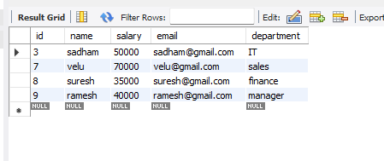
- Use a subquery to list customers who placed more than 2 orders.
select * from orders1 where customer_id in (select customer_id from orders1 group by customer_id having count(*) >2);
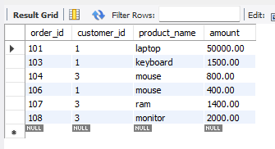
- Fetch the highest-priced product using a subquery in WHERE.
select * from products where unit_price = (select max(unit_price) from products);
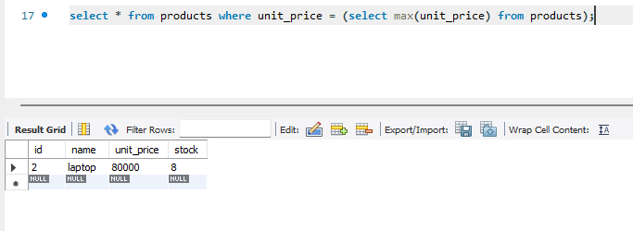

- Create a subquery that returns the total order value per customer.
select distinct customer_id, (select sum(amount) from orders1 o2 where o2.customer_id = o1.customer_id) as total_amount from orders1 o1;
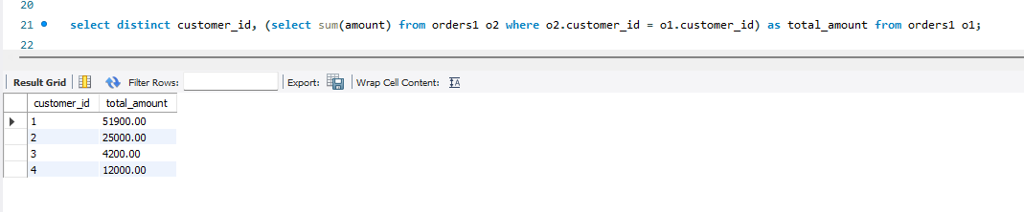
- Use a correlated subquery to list employees earning more than their manager.
select * from employees2 e1 where salary > (select salary from employees2 e2 where e2.employee_id = e1.manager_id);
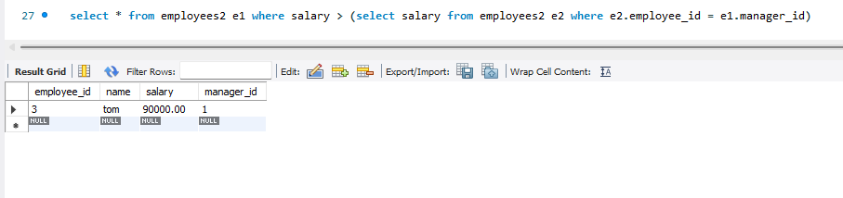
- Write a query to check if a product exists in the orders table using EXISTS.
select * from products p where exists (select 1 from orders o where o.product_id = p.id);
